**Property Detailed Page**

We are catering to the luxurious segment of the market. The look and feel should emanate sophistication and simplicity. Don’t want to display too much information. Whatever shown on screen should be valuable in decision making process. Theme of Adani Shantigram looks good.

Hero screen with 1 big image of the property.

Buttons on top of the images - position of share and download brochure.

Button - Shortlist, add to visit, Share brochure, etc.

Project name on top left corner of the screen.

Score of project matching on right side of project name.

No need for RERA, price,

4BHK, size, possession, budget, location. - Dealbreakers.

Showcase dealbreakers filter items below the image

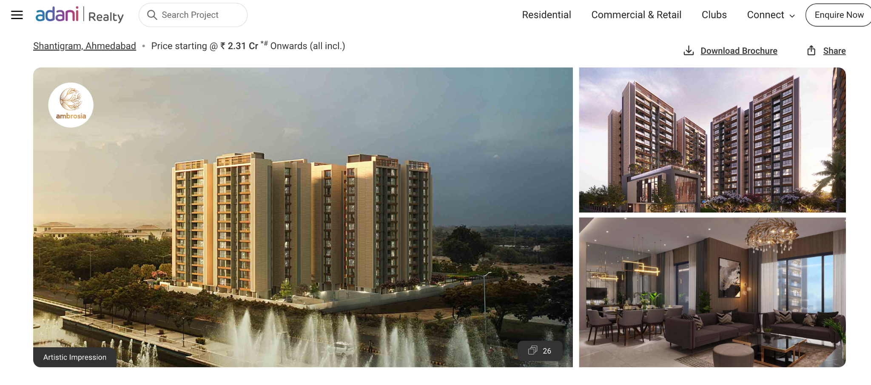

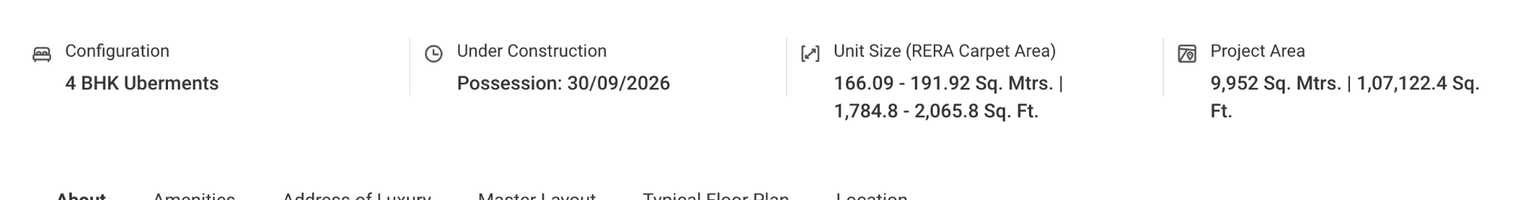

Display the parameters in some other terms - instead of percentage or pointers.

Green round with matching score.

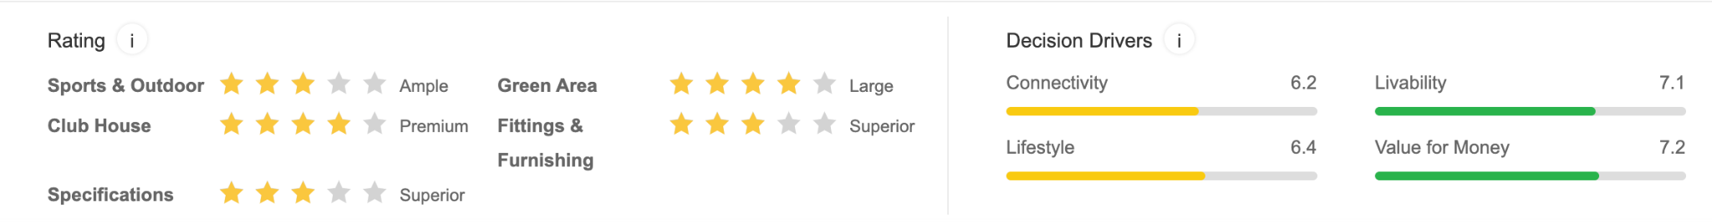

Use LLM to generate personalized project info specific to matching the customers requirements.

Create a prompt using the scoring parameters. Send prompt. Generate output.

Add 1 page in the start of the developer brochure. This page will contain details about SSC along with details of the project and why it is good for the client. Content will be static. Why is it a good purchase as per SSC.

Add share button to share the link of property. Customer should only be able to see that particular link. Disable navigation to any other page.

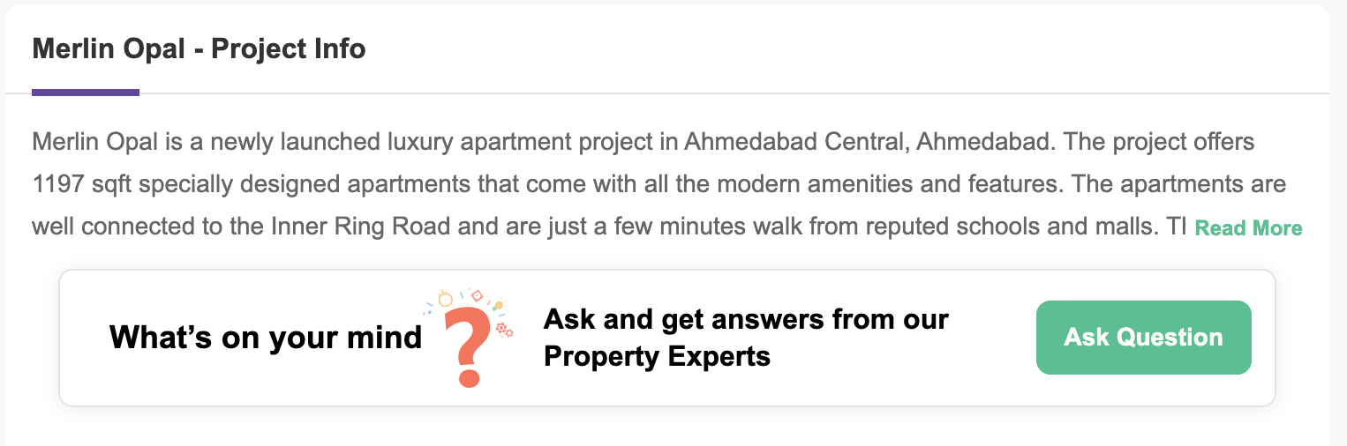

Plan a visit button will hover on the screen



**Layout and diagrams**

Show options of all the floor plans like below. Show master layout of the property.

Bifurcate between floor plan and unit plan. Keep in the same or different sections.

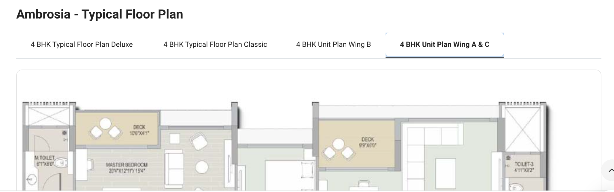

Location header. Show the location map below master layout.

Minutes to commute

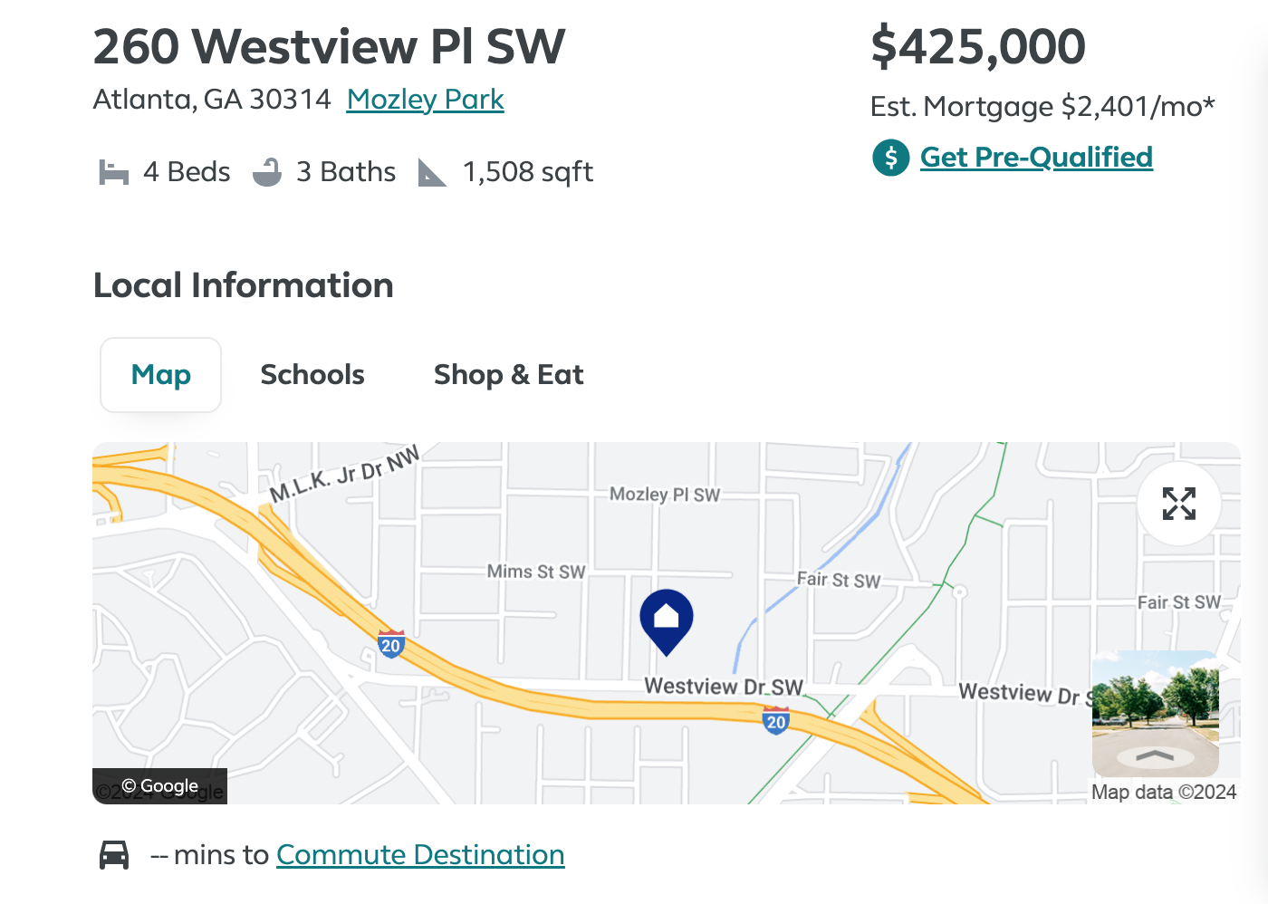

Use icons to display important information

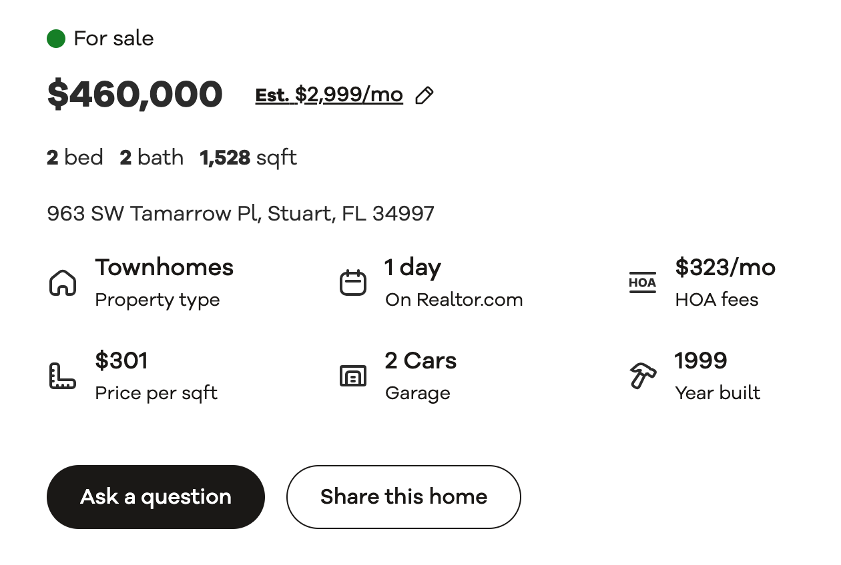

List of amenities. The color scheme looks very rich. Ambli road properties color scheme. Gold color.

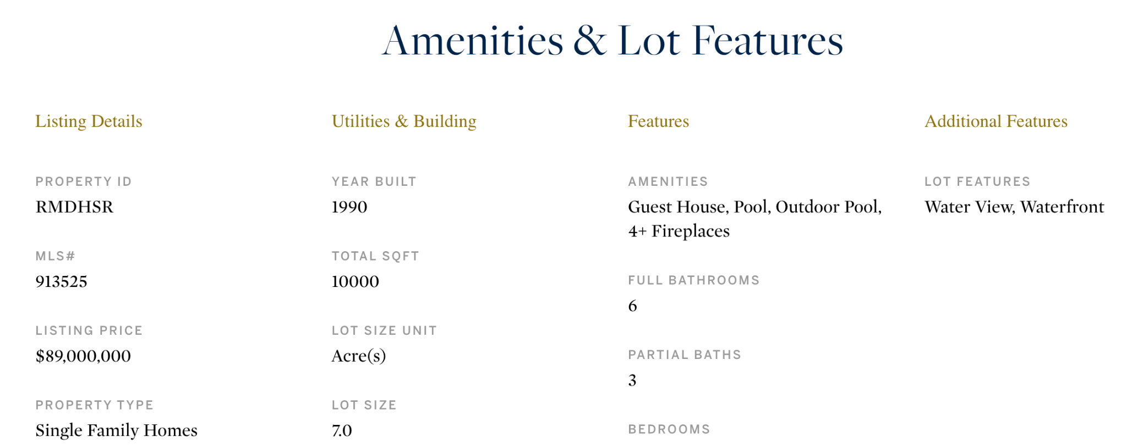

Display pricing information. Fetch data from database. Perform some primary calculations before displaying.

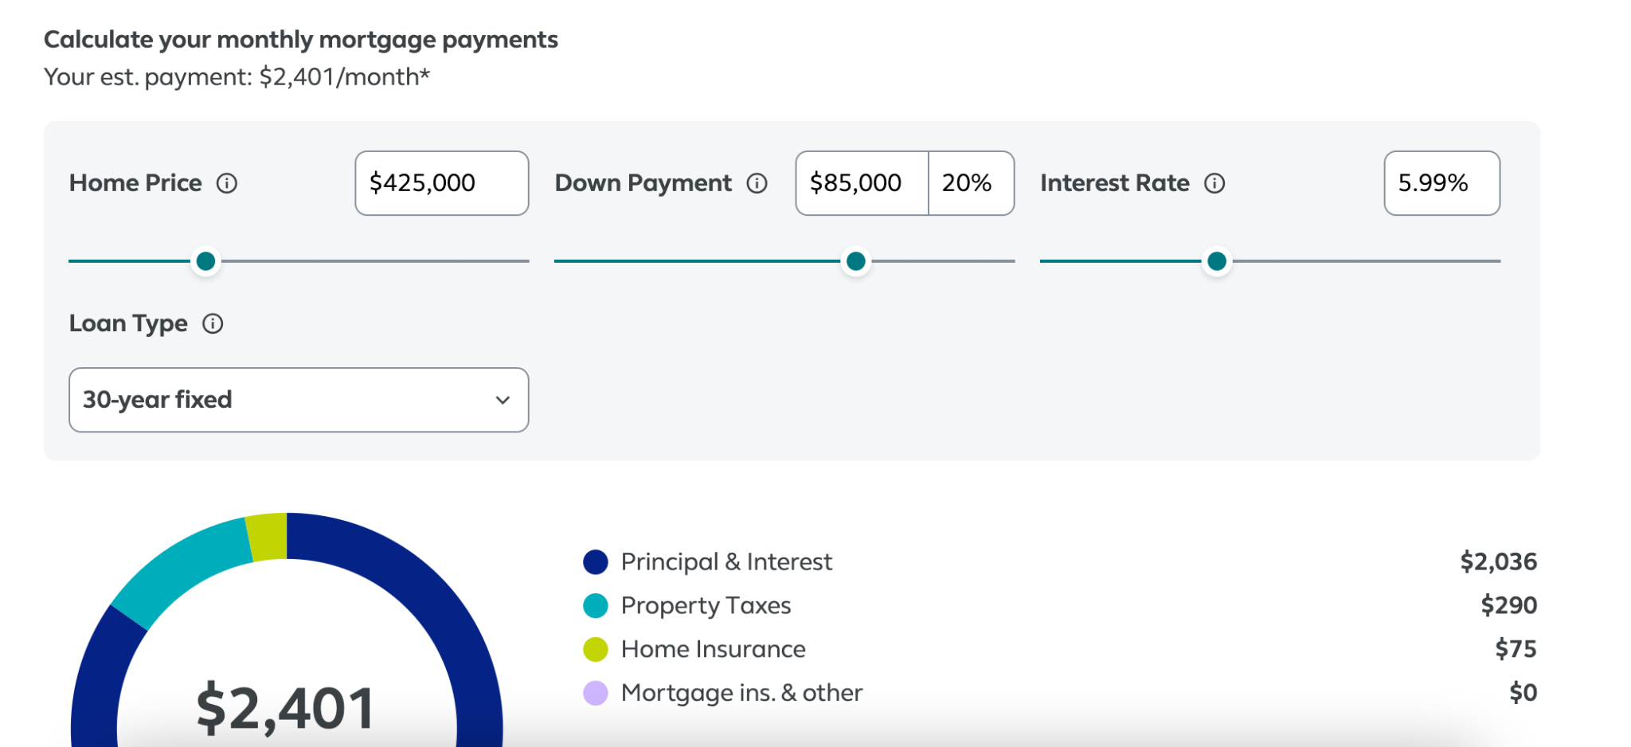

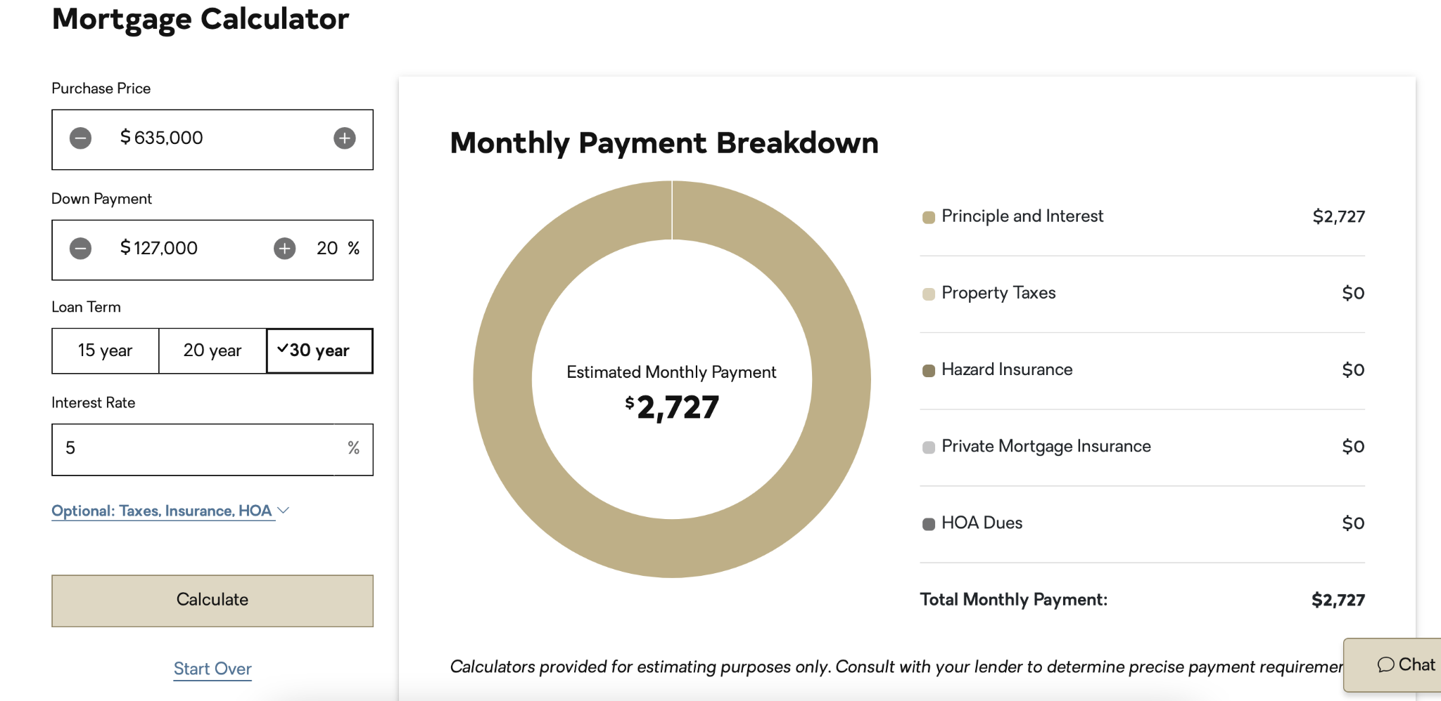

Showing more images of properties. Where to display. How many to display? Group images based on apartment type. Outdoor, indoor?

Google map API used to calculate distance. Automate the distance calculator based on client information. <https://www.compass.com/listing/83-jane-street-manhattan-ny-10014/1587892370923161761/>

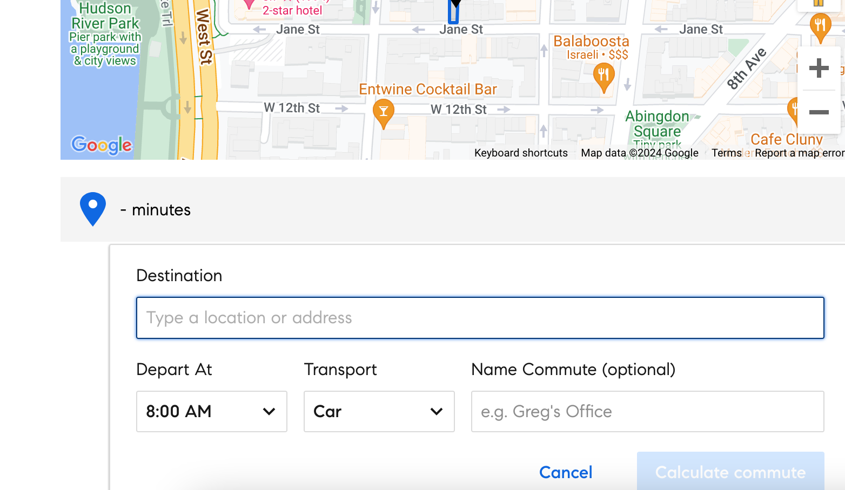

Note down the interactions that take place while interacting with a client. Example - using calculator, using google maps, taking photos? Any other apps? What are the main concerns / questions raised by the client? We need to answer all those client questions on the detail property page.

Comparison between built up and super built up?

Image display options

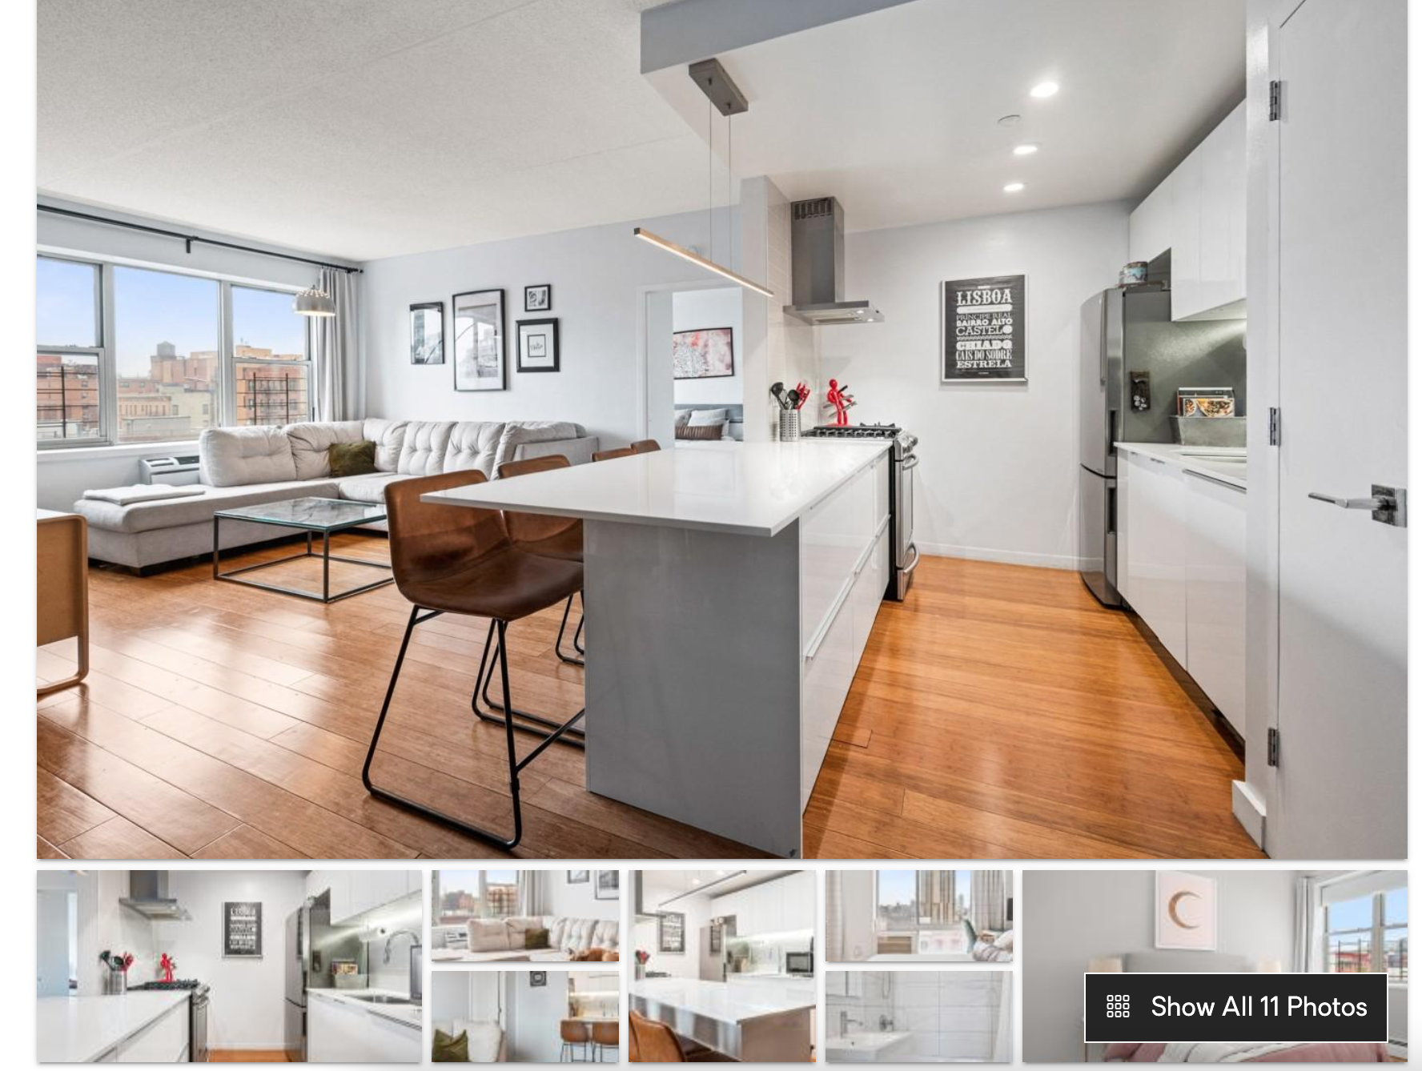

Reference links:

<https://www.squareyards.com/ahmedabad-residential-property/merlin-opal/5522/project>

<https://www.adanirealty.com/residential-projects/ahmedabad/ambrosia>

<https://www.zillow.com/homedetails/703-Fletcher-St-Austin-TX-78704/29473323_zpid/>

<https://www.realtor.com/>

<https://www.sothebysrealty.com/eng/sales/usa>

<https://www.trulia.com/home/260-westview-pl-sw-atlanta-ga-30314-65440803>

<https://www.compass.com/listing/83-jane-street-manhattan-ny-10014/1587892370923161761/>

<https://www.century21.com/property/1787-madison-avenue-501-new-york-ny-10029-REN028360782>

<https://www.opendoor.com/homes>